Press Release for immediate release

Space Exploration Masters Awards Ceremony 2018 Puts Spotlight on New Space Players

ESA’s Space Exploration Strategy Incorporates Partnership Between Humans and Robots

Space is a key asset for Europe as it stimulates technical innovation and inspiration, and increases the understanding of our planet and the Universe. The European Space Agency’s (ESA) vision positions space exploration as a global endeavour, which benefits society at large. In doing so, ESA focuses on a destination-driven space exploration strategy for low Earth orbit (LEO), the Moon and Mars. The Space Exploration Masters, initiated by ESA and AZO, is Europe’s first innovation competition dedicated to space exploration. The awards ceremony on 30 October 2018 in Bilbao brought new business ideas and personalities on stage. ESA-Astronaut Matthias Maurer held the keynote and presented the awards to the winners.

Bilbao, 30 October 2018 – The future of space exploration has been the subject of ESA’s Space for Inspiration Conference taking place in Bilbao, Spain, from 29 – 31 October. According to ESA, space exploration is the ultimate testing ground for many technologies, such as efficient energy production, robotics, life support systems and resource utilisation – to name just a few. Space exploration is thus not about robots versus humans. It’s about a partnership between humans and robots.

The Space Exploration Masters, initiated in 2017 by ESA and AZO Anwendungszentrum GmbH Oberpfaffenhofen, is Europe’s first innovation competition dedicated to space exploration. This year, the Space Exploration Masters was seeking innovative business ideas that provide major benefits for global society and the economy, focusing on ESA’s space exploration strategy and its three destinations: Low Earth Orbit (LEO), the Moon and Mars.

“Space exploration contributes to the competitiveness and growth of the European industrial sector by pushing the frontiers of knowledge and developing new technologies in other fields of economic value. The innovative business cases and applications presented in the Space Exploration Masters have clearly demonstrated its potential to strengthen this economic dimension of space exploration for the benefit of society a large,” states Bernhard Hufenbach, Lead Strategy and Innovation, ESA Directorate of Human and Robotic Exploration, ESA.

The Space Exploration Masters has the strong support of world-class institutional and industrial partners. All partners - such as Luxembourg Space Agency, Stevenson Astrosat Ltd., Huntsville Madison County Chamber Alabama, Airbus, Air Liquide, Merck KGaA, Darmstadt, Germany as well as many more - offered a variety of application topics within five challenges for their individual prizes.

“Specifically, the commercialisation of space exploration has experienced a major push forward through new business models over the last 20 years,” emphasises Thorsten Rudolph, Managing Director of AZO Anwendungszentrum GmbH Oberpfaffenhofen, the organiser of the Space Exploration Masters. “That is also reflected in the remarkable entries submitted to the Space Exploration Masters 2018, representing the innovative spirit of the new space economy! I am excited to see these innovative ideas turn into businesses with the support of our strong world-class partners.”
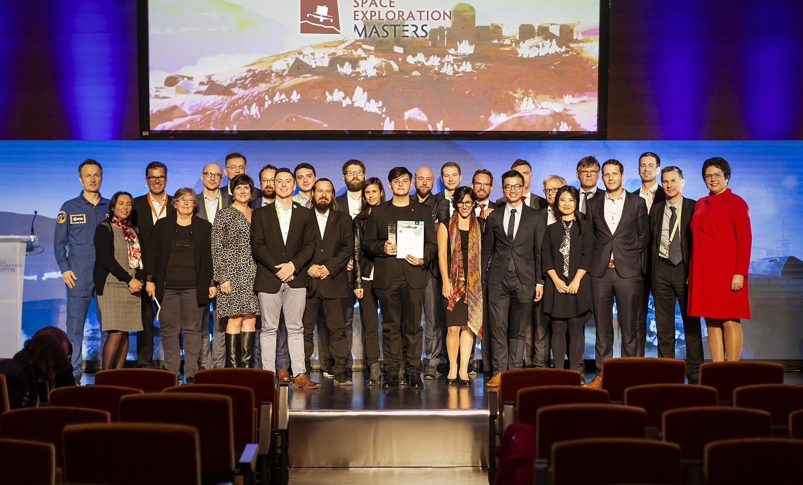
During the Space Exploration Masters Awards Ceremony, the winning ideas were recognised by high-ranking industry and institutional representatives and ESA-Astronaut Matthias Maurer. The following winners were presented with awards in the five challenges:
- Health & Food Challenge by ESA, WHO, CNES and ASI: EneMiSInFood — Energy-Efficient, Microwave-Assisted Sterilisation of In-Space Food by Georgios Profitiliotis
- ESA & Commercial Partners Challenge: Alginity– Space-grade Bioreactor and Harvester by Maria Teresa Perez Zaballos & Team
- SpaceResources.lu Challenge: Innovative, Cost-Effective Smallsat Solutions for Space Exploration and Exploitation by Jordan Vannitsen & Team, ODYSSEUS Space
- Astrosat & Huntsville Challenge: Meteoroid Complementary Descent Module – An Internal SNC Dream Chaser Module for Landing Space Resources by Mattia Barbarossa
- Sustainable Exploration Challenge by Airbus, Air Liquide, Merck KGaA, Darmstadt, Germany as well as ESA Space Solution Prize: Alginity – Space-grade Bioreactor and Harvester by Maria Teresa Perez Zaballos & Team

The overall winner, Alginity, was announced live on stage during the awards ceremony. The audience had the chance to vote for their favourite idea in order to choose the overall winner of the Space Exploration Masters 2018.

About Space Exploration Masters
In 2017, AZO has launched the Space Exploration Masters on behalf of the European Space Agency (ESA) and in line with the goals of the ESA Space Exploration Strategy, in cooperation with strong world-class partners. The Space Exploration Masters is an international competition to identify best technology transfer business successes, as well as to empower and foster business innovation around space exploration activities in Low Earth Orbit (LEO), on Moon, Mars, or beyond – for the benefit of society and Earth. For more information space-exploration-masters.com.

About AZO
AZO Anwendungszentrum GmbH Oberpfaffenhofen is an international networking and branding company initiating the most important space-related innovation competitions with more than 15,000 participants, over 200 industrial & public - and 400 international stakeholders. The Masters Series, presented by AZO consists of European Satellite Masters (ESNC), Copernicus Masters, Space Exploration Masters, and INNOspace Masters. AZO has been supporting entrepreneurship with more than 148 company foundations to date and the creation of 2,000 high-tech jobs in Bavaria with an annual turnover of about EUR 150 million. Additionally, AZO runs a very successful business angel network which invested more than EUR 130 million Venture Capital in 2016/17 as well as the ESA Incubation Centre (ESA BIC) Bavaria. For more information, please visit www.azo-space.com.
Press contact: | AZO
Regine Heue | Anwendungszentrum GmbH Oberpfaffenhofen
Head of Marketing & Communications | Friedrichshafener Str. 1
press@azo-space.com | 82205 Gilching

