Press Release:
Copernicus Masters 2019 Submissions Open 1 April
Sustainable Development with the Copernicus programme
The UN Sustainable Development Goals can only be achieved with reliable, up-to-date information on topics such as climate, water, food security, marine, forests and urban planning. Most of this must come from satellites. Copernicus, Europe’s Earth observation programme, provides open access to such data for the development of solutions in a wide variety of domains. The fact that all these data are not only reliable but also completely free of charge holds huge potential for the creation of innovative products and services. At the same time, it gives companies, entrepreneurs and startups many opportunities to create sustainable business concepts.
The Copernicus Masters awards applications and solutions that use Copernicus data to tackle important challenges, with 2019 submissions opening on 1 April.
Oberpfaffenhofen, 1 April 2019 – The demand for Earth observation (EO) data is exploding in order to find innovative solutions for today’s challenges such as climate change, food security or water supply. With more than 15 terabytes of free EO data generated by the Copernicus programme every day, the Copernicus services deliver near-real-time data on a global level - contributing towards the sustainable management of the environment. Simultaneously, the Earth observation industry is constantly growing. New data platforms are being developed to receive and process the huge amount of satellite data collected from the Sentinels - and other contributing missions. These data platforms are established on the cloud and work with Artificial Intelligence (AI) and Machine Learning, enabling the development of new applications in the EO sector.
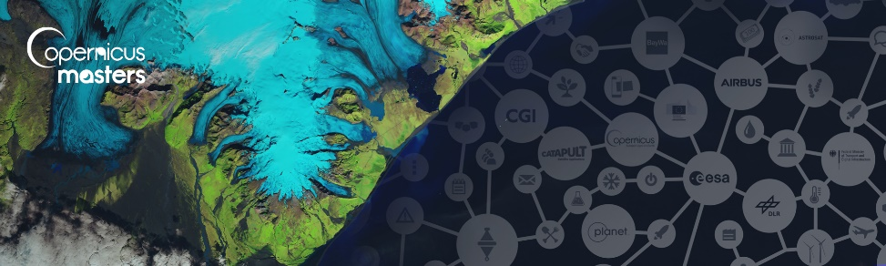
The Copernicus Masters 2019 – Europe’s leading innovation competition for Earth observation (EO) – is searching for such outstanding applications, solutions, and business concepts from future-oriented SMEs, startups, universities and individuals in the fields of business, research, and higher education.
From 1 April to 30 June, participants in the Copernicus Masters 2019 can submit their innovative EO solutions to 8 challenges offered by the following world-class partners: European Space Agency (ESA), the German Aerospace Center (DLR), Astrosat, Planet, BayWa, and Airbus together with sobloo and the German Federal Ministry of Transport and Digital Infrastructure (BMVI).
“The Copernicus Masters is the innovative driver for future-oriented applications and business concepts using Earth observation data. This creates socio-economic benefits through public services all over Europe. Besides, it supports business ventures and high-tech jobs in Europe’s digital economy,” states Josef Aschbacher, Director of ESA’s Earth Observation Programmes. ESA is an

initiating partner of the Copernicus Masters and has set a challenge for participants every year since 2011.
Participants can demonstrate their innovative use of Earth observation data across a wide variety of challenge topics, including the fields of future EO, Artificial Intelligence (AI), machine learning, energy, health, sustainable living, smart farming, and digital transportation, as well as maritime, defence & security.
“Since 2011, the Copernicus Masters competition has evolved into the leading innovation platform for promoting user uptake of Earth observation data in a commercial, societal and sustainable context. Each year, it showcases new solutions and trends, serving as an integral part of an international EO innovation network,” adds Thorsten Rudolph, Managing Director of AZO, the competition organiser.
Together with cash prizes, challenge winners will receive access to an international network of leading Earth observation organisations, substantial satellite data quotas, and business development support worth more than EUR 450,000 in total. The Overall Winner will receive an additional cash prize of EUR 10,000.
For more details on this year's challenges, prizes, and partners, please visit www.copernicus-masters.com. For more information, please see space-of-innovation.com. Additional information on the Copernicus programme is available at: www.esa.int/copernicus and www.copernicus.eu.

About the Copernicus Masters
AZO Anwendungszentrum GmbH Oberpfaffenhofen launched the Copernicus Masters in 2011 on behalf of the European Space Agency (ESA) and with the strong support of world-class partners. The Copernicus Masters is an international competition with the objective to drive Copernicus User Uptake of Earth observation (EO) data and thus respective business cases. With partners such as European Space Agency (ESA), the European Commission (EC), the German Aerospace Center (DLR), CGI, Planet, BayWa AG, Stevenson Astrosat Ltd., Airbus, and the German Federal Ministry of Transport and Digital Infrastructure (BMVI), the competition awards prizes to innovative solutions for business and society. With the expansion of the Copernicus Space Component every year, new prize categories enable solutions that tackle global challenges. For more information www.copernicus-masters.com.

About AZO – Your Partner in Competition & Innovation
AZO Anwendungszentrum GmbH Oberpfaffenhofen is an international networking and branding company initiating the most important space-related innovation competitions with more than 15,000 participants, over 200 industrial & public - and 400 international stakeholders. The Masters Series, presented by AZO consists of the Galileo Masters, Copernicus Masters, Space Exploration Masters, and INNOspace Masters. Additionally, AZO organises the Copernicus Hackathons by the European Commission. AZO runs a very successful business angel network which invested more than EUR 50 million Venture Capital in 2018. Additionally, AZO manages it’s ESA Incubation Centre (ESA BIC) Bavaria. This incubation programme has supported more than 150 company foundations solely in Bavaria to date. For more information, please visit www.azo-space.com.

Press contact: | AZO
Regine Heue | Anwendungszentrum GmbH Oberpfaffenhofen
Head of Marketing & Communications | Friedrichshafener Str. 1
marketing@azo-space.com | 82205 Gilching/Oberpfaffenhofen

